ASSIGNMENT-1

* CREATE THREE INSTANCE

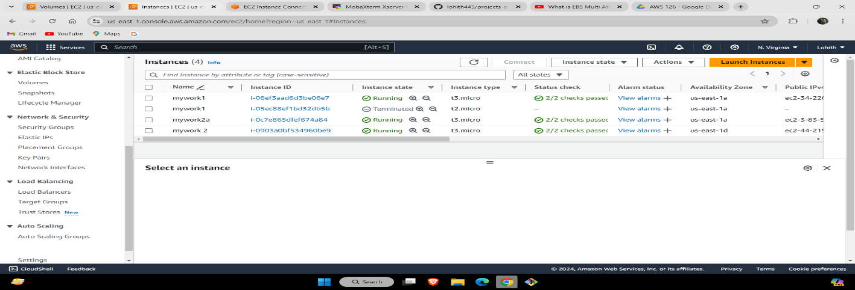

* CREATE EFS

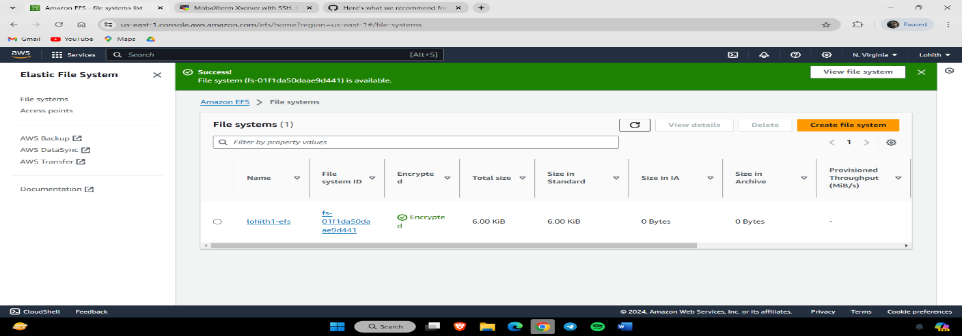

* ATTACH EFS MOUNT TO TWO EC2 INSTANCE

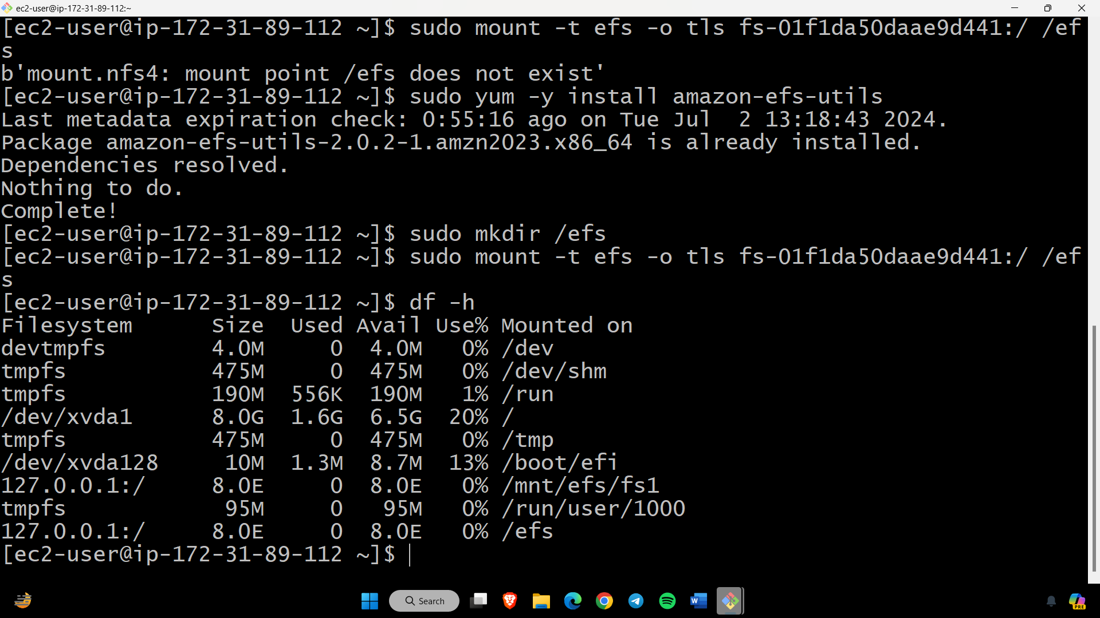

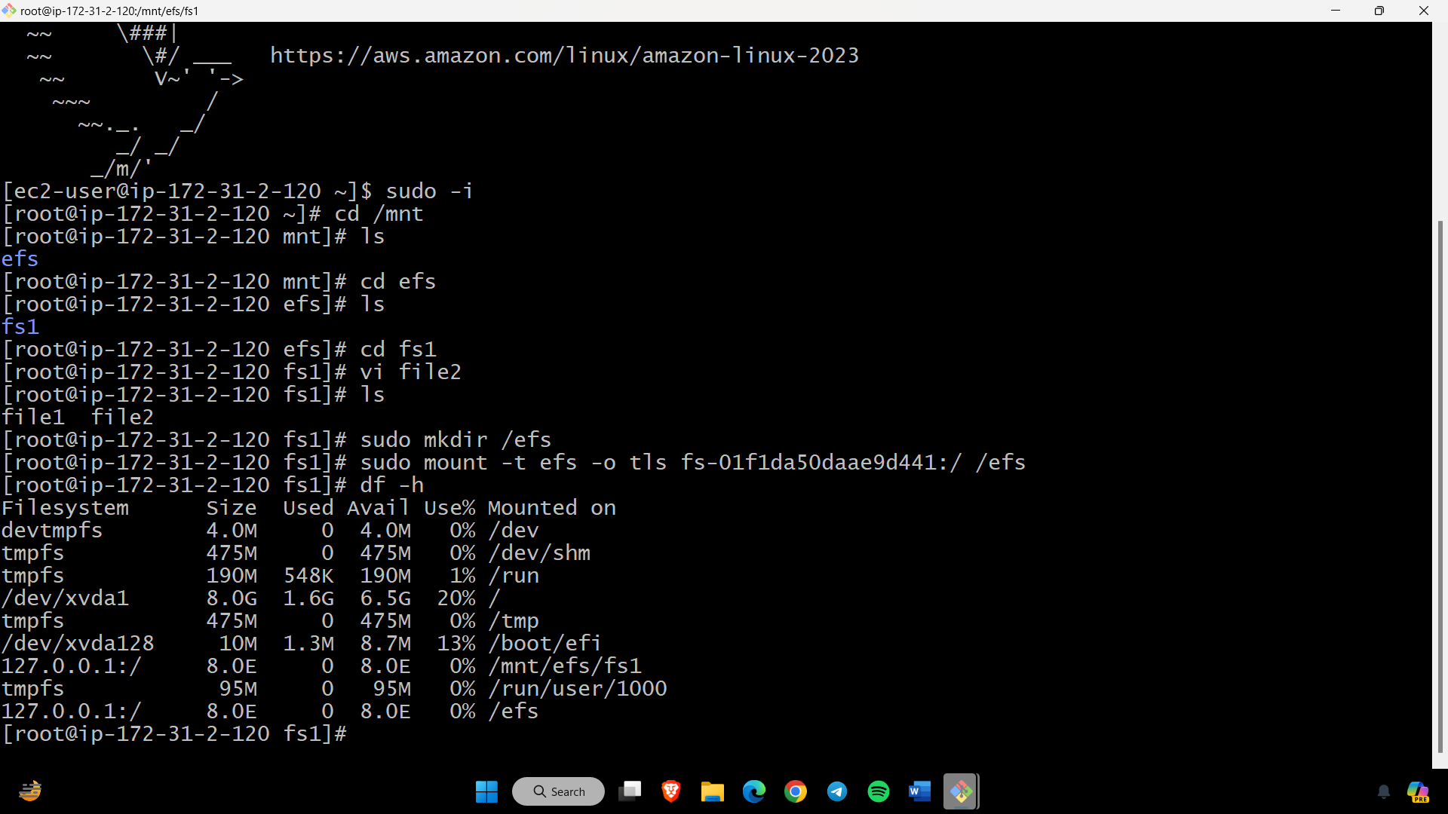

* CREATE EBS

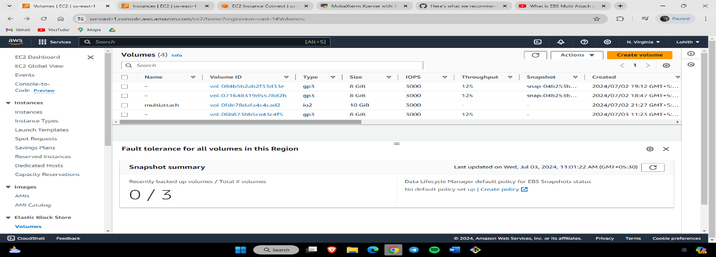

* ATTACH TWO INSTANCE TWO ONE EBS

